To run the throttle valve code under the proposed ADRC, you have to follow the following steps:

1. Open and then run System_Setting.m to save the system parameters in workspace as shown below: (run without changing any value)

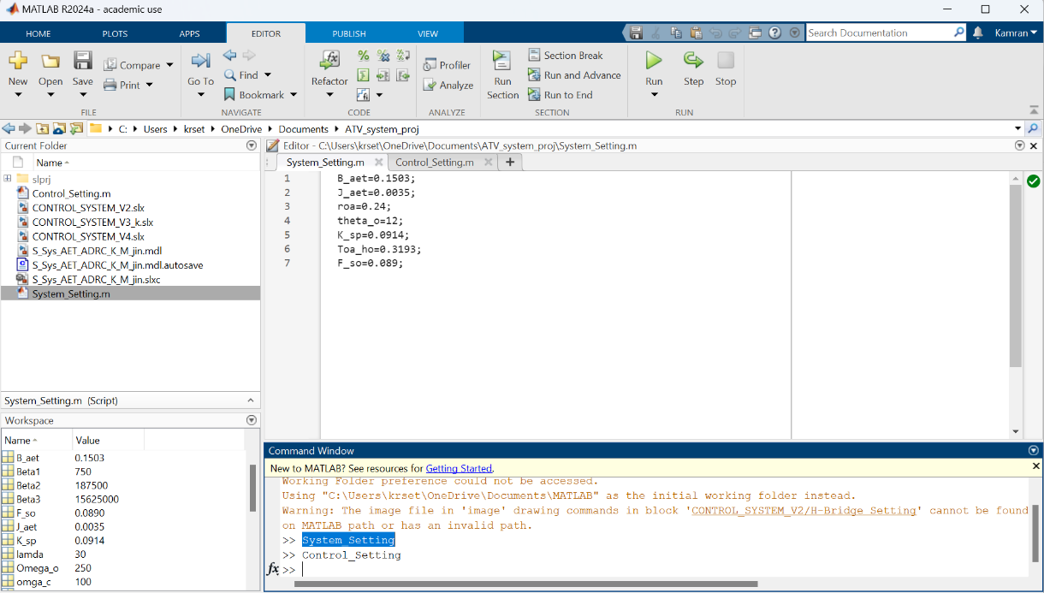

3

2

1

1. Open and then run Control_Setting.m to save the control parameters in workspace as shown below:

The control parameters have two gains including Omega_o and omega_c

that should be tuned gradually. So, you can start with the small gains like Omega_o= 15 and omega_c=5. If you see a poor performance, you should increase those gains gradually like Omega_o= 20 and omega_c=10. Please keep going till getting a better performance.

4

3

2

1

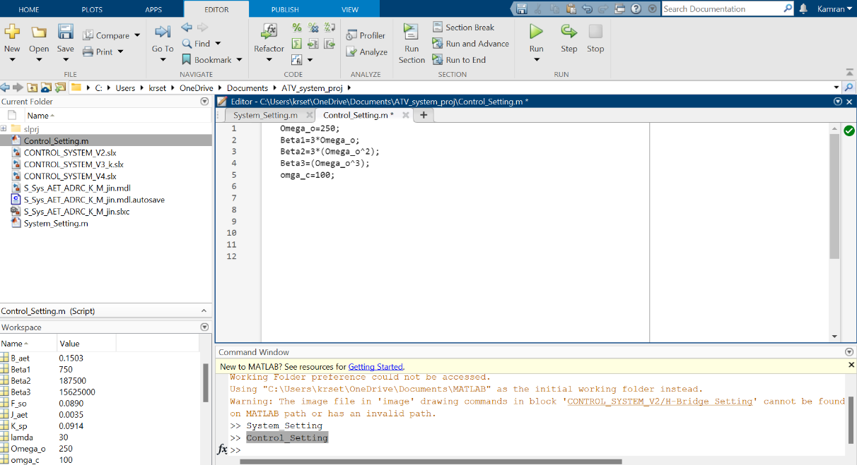

1. After running .m files, you can run the main code of the project (named by CONTROL_SYSTEM_V4).